**Exercise 01 🡪 Nouns , Verbs , Tables**

A new Cable TV company called VTV is providing over 100 entertainment TV channels to customers. Any person can become a customer by registering with VTV. The customer has to provide customer details and the package ( channels he wishes to see ) during the registration. The customer is provided with a unique customer number. The customer details are stored in the customer table and the package details selected by the customer are stored in the subscription table. Once a month the VTV sends the customer a detailed bill. This is produced using the data stored in the Subscription Table, Customer Table, and Channel details Table. The customer can login to VTV's website and perform several online tasks. The customer can add new channels to the subscription he has. He can remove channels from his subscription. In both cases the Subscription Table should be updated. In addition, the customer can provide a list of channels that he wants to get a detailed weekly TV schedule by email. These details are also stored in the Subscription Table. The customer can pay the monthly bills online using a credit card. He has to provide the credit card details and the amount to the system. The payment details are stored in the Payments Table. Every week VTV sends customers who have requested detailed TV schedules the details by email. TV schedules are stored in the Channel details Table.

|  |  |
| --- | --- |
| Subscription | |
| **Responsibility** | **collaboration** |
| Package details | customer |
| Add new channels | Customer |
| Remove channels | Customer |

|  |  |
| --- | --- |
| Customer | |
| **Responsibility** | **collaboration** |
| Providing details |  |
|  |  |

|  |  |
| --- | --- |
| Channel detail | |
| **Responsibility** | **collaboration** |
| Add channel details |  |
|  |  |

|  |  |
| --- | --- |
| Payment | |
| **Responsibility** | **collaboration** |
| Add payment details |  |
| Provide credit card details | customer |
|  |  |

|  |  |
| --- | --- |
| Report | |
| **Responsibility** | **collaboration** |
| Generate detail bill | Subscription , customer, channel |
|  |  |

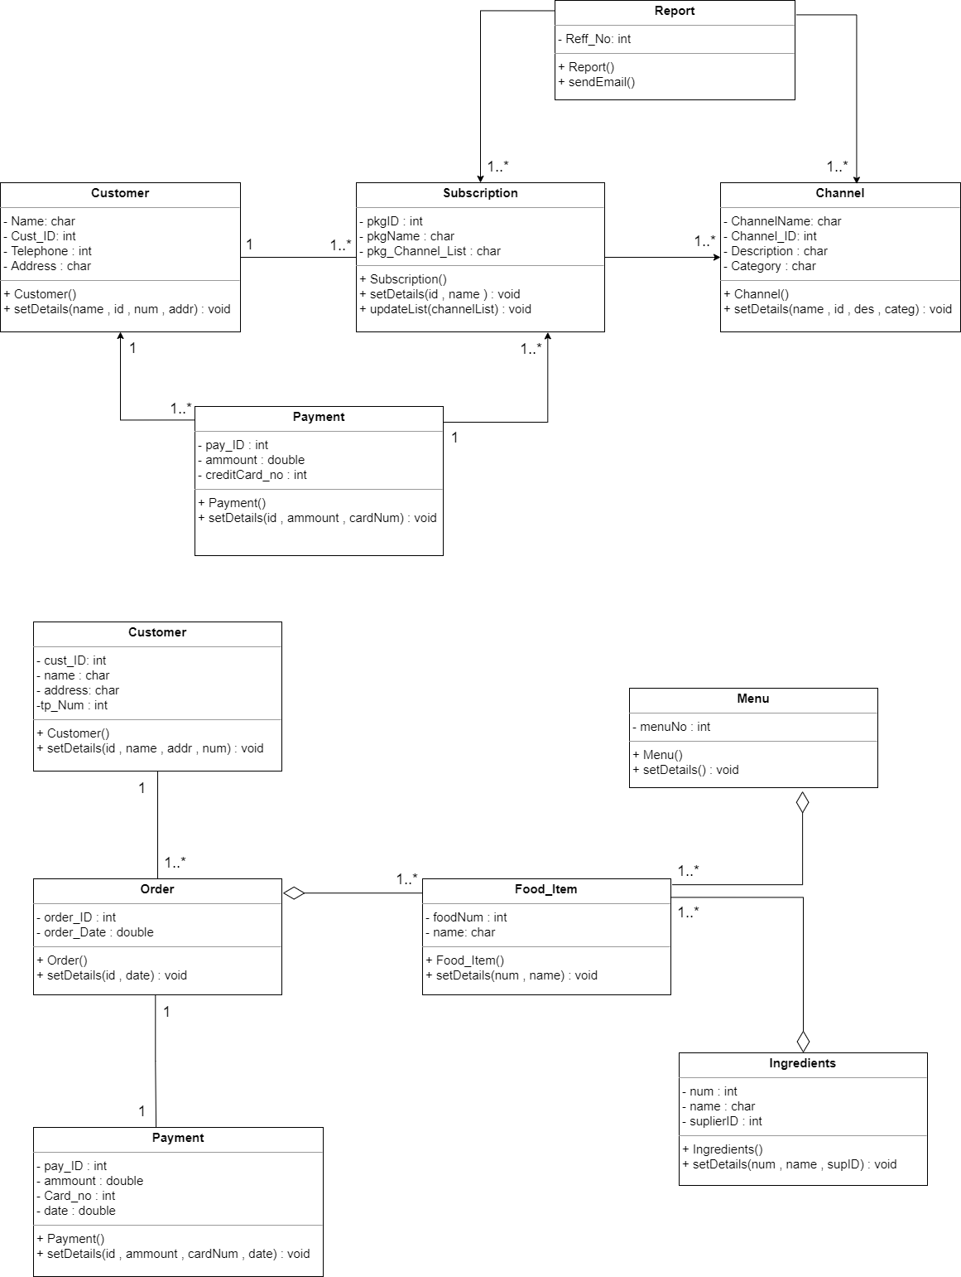

**Exercise 01 🡪 Nouns , Verbs**

Food Delight is a famous restaurant situated in Colombo suburbs area. Both Locals and tourists both come to enjoy breakfast, lunch, and dinner from this delicious restaurant. To give a better service for all the customers it has a new facility availability to place online orders, and the order will be delivered to the customers doorstep.

Customer can view the menu available online. Customer can select the food items he wishes and to place the order along with filling the delivery and contact details. When the customer places the order, the manager can view that order. The manager is responsible for the timely delivery of the order. the manager will forward the order to the head chef in the kitchen. If all the ingredients are available, the head chef will assign the order to junior chefs. If the ingredients are not available to fulfil the order, the head chef will reorder the quantities and an automatic email will be forwarded to the manger indicating that the particular order will be delayed 30-45 minutes extra. The Manager can call the customer and inform the delay of the order.

Once the order is prepared, the delivery team can print the order details and the head chef informs the manager of the completion of the order. The delivery team will deliver the order to the customers. Payments will be handled online when the customer orders. The customer can use credit or debit card to do the online transaction.

